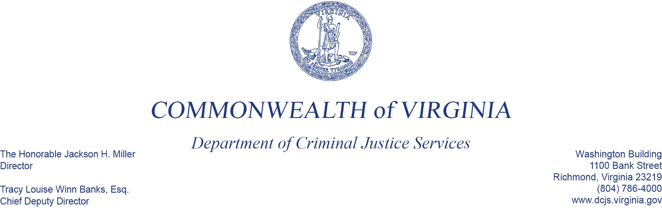
To: Criminal Justice Services Board Grants Committee
From: Tracy Matthews, Law Enforcement Training and Grants Supervisor, Acting Manager
Date: June 2, 2022
Re: Project Safe Neighborhoods

In 2021, DCJS became the Fiscal Agent for the Federal Office of Justice Program’s (OJP), Project Safe Neighborhoods (PSN) Grant Program. The programmatic activities of this project is overseen by the United States Attorneys Office’s of the Eastern and Western Districts of Virginia. The program focuses on providing strategic approached to addressing crimes associated with gun and gang violence.
The grant recommendations you have before you are the result of a solicitation/funding opportunity from the Eastern District of Virginia. The budget for these awards total $244,440.
The U.S. Attorney’s Office convened a review committee and voted on the submitted applications. The recommendations of the committee are then presented to the federal program monitor for final approval. No vote is required by this committee.
As the fiscal agent, DCJS is responsible for the overall supervision of the funding and overseeing the federal reporting on the grants.

